Project Initialization and Planning Phase

Date | 02-02-2026
Team ID | LTVIP2026TMIDS57015
Project Name | Dog Breed Identification using Transfer Learning
Maximum Marks | 3 Marks

Define Problem Statements:

The problem statement for the following project can be any of the below two:

- To create an online platform to categorize the dog breed available for adoption based on the uploaded image.
- A veterinarian needs assistance in identifying the breed of the dog brought in for health checkup.


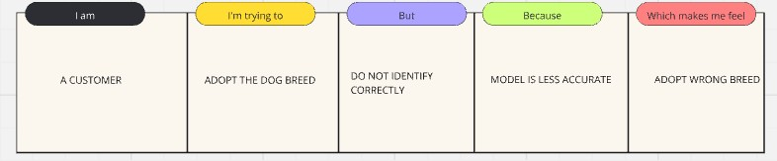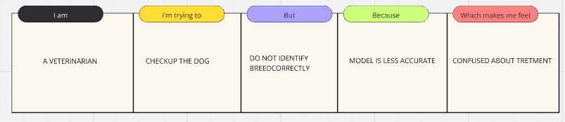

Problem Statement (PS) | I am (Customer) | I’m trying  to | But | Because | Which makes me feel
PS-1 | Customer | Classify dog breed | Do not identify correctly | Model is less accurate | Prediction wrong
PS-2 | Veterinarian | Checkup the dog | Did not identify the dog breed correctly | Model is less accurate | Confused about Treatment

